Safety Guidelines

for Facility User Groups
Table of Contents
Safety Guidelines for Facility User Groups 1
Introduction 2
General Information 3
COVID-19 Transmission 3
COVID-19 Symptoms 3
Hierarchy of Controls 4
Appendix A – Safety Guideline Administration 5
Appendix B – Hygiene Controls 6
General Personal Hygiene Protocol 6
Enhanced Cleaning 6
Face Masks 6
Shared Equipment and Personal Items 7
Appendix C – Gatherings and Spectators 8
Group Sizes 8
Spectators 8
Physical Distancing 8
Appendix D – User Group Outbreak and Illness Plan 9
Outbreak and Illness Protocol 9
Contact Tracing 10
Appendix E - Definitions 11
Appendix F 12
Appendix G – Facility Maps 13

Safety Guidelines for Facility User Groups
In order to mitigate transmission of COVID-19 and other diseases the Township of Langley has reviewed the most recent information from various sources such as: PHO, BC Restart Plan, ViaSport, WorkSafeBC, and BCRPA to produce this document with the goal of establishing a safe and healthy environment for both staff and user groups at Township of Langley facilities. The Township will modify this document as guidance changes or to address health and safety concerns. All groups using Township of Langley facilities will adopt these guidelines to minimize ambiguity or confusion around the current guidance and compliant behaviour.
With respect to sport-specific guidance, every sports group must strictly adhere to their National/Provincial Sports Organizations’ guidance. Township facility rules, are designed to dovetail into those guidelines and in some cases, meet or exceed that guidance from a health and safety perspective.
While the Township is providing assistance to maintain the core safety plan documentation, it is the responsibility of each user group to prepare, update, and ensure ongoing compliance with this document. To ensure completeness, a user group should add any necessary information not covered in this document into “Appendix F”.

Introduction
By order of the Provincial Health Office (PHO), all organizations must develop a COVID-19 Safety Plan for their operations. The Township of Langley is committed to providing the public and facility users a safe place to gather in a manner that aligns with BC’s Restart Plan, the Provincial Health Officers (PHO) guidelines, and other safety requirements established by WorksafeBC that the Township is required to follow.
The health and safety of our community is the primary lens through which the Township bases its decisions with respect to its pandemic response. Therefore, the Township of Langley has established this template to eliminate, reduce and/or control COVID-19 related hazards. This safety guideline is intended to assist facility user groups in laying a strong foundation for the safe usage of Township of Langley facilities.
The BC’s Restart Plan has highlighted the 5 principles for every situation. These principles were considered in the development of this document.
As the facility owner, it is the Township’s prerogative to establish rules that it deems necessary to ensure the health and safety of our community. Facility rules may impose restrictions over and above what is stipulated in a public health order, sport-specific guidance, or other 3rd party guidance that may be available.
Should a contradiction exist between available 3rd party guidance and the guidance outlined in this document, the Township will assess the information through the lens of health and safety and may choose update this document accordingly.
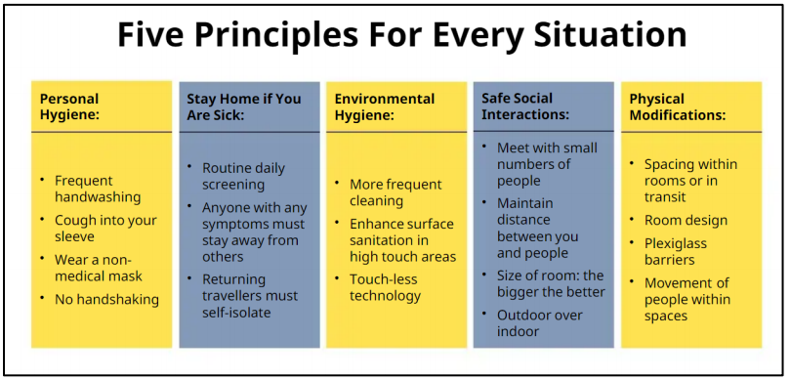

General Information

COVID-19 Transmission
COVID-19 is transmitted via liquid droplets when a person coughs or sneezes, but also potentially when they are talking in very close proximity to another person. The virus in these droplets then can enter the body of another person when that person breathes in the droplets or when the droplets touch the eyes, nose, or throat of that person.
COVID-19 can also be transmitted through droplets in the environment if someone touches a contaminated area, then touches their face without cleaning their hands. The virus does not enter the body through skin, it enters through the eyes, nose, or mouth when the person touches their face. Unfortunately, human beings touch their faces very often throughout the day, much more than they realize. Therefore, regular handwashing and cleaning of high touch surfaces is extremely important.
Droplet transmission is much more likely when in close contact in an indoor setting. Transmission is less likely in an outdoor setting, where there is more space for people to keep physically distanced.
However, in the context of sports, even outdoors there can be risks from high-touch surfaces because many sports involve objects that are normally shared among players, coaches, or volunteers (balls, pucks, equipment, etc.).

COVID-19 Symptoms
The symptoms of COVID-19 are similar to other respiratory illnesses including the flu and common cold. COVID-19 symptoms can range from mild to severe. Sometimes people with COVID-19 have mild illness, but their symptoms may suddenly worsen in a few days. Research shows that some symptoms are more likely related to COVID-19 than others.

Key symptoms of COVID-19 include:
Fever of chills | Cough | Extreme fatigue or tiredness | Nausea
Headache | Loss of smell or taste | Difficulty breathing | Vomiting
Sore throat | Loss of appetite | Body ache | Diarrhea

Hierarchy of Controls
When considering how to reduce the risk, there is a hierarchy of controls that should be followed. It's important to follow the hierarchy rather than start with the easiest control measures.
The Township has used the WorkSafeBC Hierarchy of Control model, shown in Figure I, to help reduce the risk of person-to-person transmission. Controls that fall into the top level of protection will be considered first but a variety of controls will be used to address the risks throughout each facility.
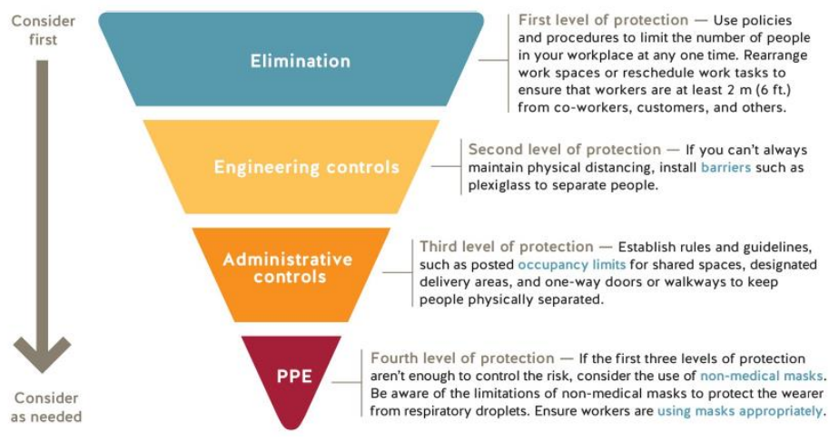
Figure 1: WorkSafeBC's Hierarchy of Controls model (https://www.worksafebc.com/en/resources/health-safety/checklist/covid19-safety-plan)

Appendix A – Safety Guideline Administration
Page left intentionally blank (user group to insert prepared Appendix A here).

Appendix B – Hygiene Controls

General Personal Hygiene Protocol
Practicing good hygiene is an essential and effective part of preventing the spread of COVID-19. Take these measures to protect yourself and others from getting sick:
- Wash your hands often (in addition to routine times such as after using the washroom, before eating and when handling food for the public);
- Cough/Sneeze into your elbow or tissue and throw away;
- Avoid touching your eyes, nose and mouth with your hands; and
- Use alcohol-based hand sanitizer if soap and water are not readily available.
- Provide a sanitizer for your staff and participants to use on a regular basis

Enhanced Cleaning
Enhanced cleaning is intended to prevent the transmission of COVID-19 by ensuring that high-traffic surfaces (sometimes referred to as high-touch points) are correctly disinfected on a regular basis. User groups are responsible for wiping down all high-traffic surfaces with sanitizer before and after their session.
Some examples of high-traffic surfaces include:
- Door Handles
- Park Gates/Fences
- Locks
- Handrails
- Push Bars
- Pens
- Bollards
Many high touch areas in recreation centres are frequently cleaned by TOL staff as part of the facility safety plan requirements and as such, user groups do not need to disinfect these areas.

Face Masks
Township of Langley requires all participants to wear face masks in or at all Township facilities. Participants can remove their masks during physical activities only if current physical distancing measures can be maintained. All coaching staff must wear face masks at all times even during the activity. Exceptions to the rules are as follows:
  - An underlying medical condition or disability which inhibits the ability to wear a face mask.
  - A person who is unable to put on or remove a face mask with the assistance of another person.
  - Children under twelve years of age.

Shared Equipment and Personal Items
- Participants have to supply their own equipment and do not share between any other participants.
- All participants must bring their own water bottle. The water fountains are currently not in use.
- Enhanced cleaning protocols, such as cleaning shared sports equipment as stipulated by various sports associations, should be completed and defined by the sports user group in Appendix F of this document.

Appendix C – Gatherings and Spectators
One of the most important factors in reducing the spread of COVID-19 is to limit the number of people gathering together and to ensure other hygiene controls like physical distancing and mask usage occurs wherever recommended by the most recent guidance from the PHO.

Group Sizes
The current facility rules limit the number of people in a designated area to a maximum of 50 individuals
Should define area/field/structure, for example one ball diamond/one soccer field.

Spectators
In accordance to the most current public health order, there are NO spectators permitted at this present time.

Physical Distancing
All participants must maintain a 3-metre physical distance from one another at all times. Those who can not maintain the required physical distance can not continue with their activity.

In some situations, sport-related guidance may permit alternative physical distancing guidance. Please refer to Appendix F for alternative guidance if it is available.

Appendix D – User Group Outbreak and Illness Plan

Outbreak and Illness Protocol
All user groups must follow a defined step-by-step procedure in the event that an individual associated with the group (manager, coach, participant, volunteer, parent/spectator) becomes symptomatic to help minimize the transmission of COVID-19.
Assessment
- All participants must complete a self-assessment before beginning each activity to confirm they are not feeling any COVID-19 symptoms.
- If a participant is unsure or if facility group self-assessment is not available, please complete the BC COVID-19 self-assessment tool https://bc.thrive.health/covid19/en.
- Managers, coaches, of safety leads may visually monitor participants to proactively identify individuals that may be showing COVID-19 symptoms at any time during the activity.
Outbreak and Illness Protocol
Prior to an activity, if a participant is feeling sick with COVID-19 symptoms:
- They should remain at home and contact Health Link BC at 8-1-1.
- No member may participate in an activity if they are showing any COVID-19 symptoms.
During an activity, if a participant is feeling sick with COVID-19 symptoms:
- Inform the designated representative from your organization.
- Go home immediately and contact Health Link BC at 8-1-1.
If a member tests positive for COVID-19:
- Follow the directions provided by public health officials.
Quarantine or Self-Isolate if:
- You have travelled outside of Canada or the province within the last 14 days.
- You have been advised to do so by public health officials.

Contact Tracing
All user groups must complete contact tracing for their event as required by public health order. Please use the Township of Langley contact tracing form located at tol.ca/covid19/facilitygroup.
- The contact information for all facility users (participants, spectators, etc.) must be collected.
- The completed form must be emailed to covid-attendance@tol.ca immediately following the completion of the event unless otherwise approved by the Township’s Emergency Operations Centre.

Appendix E - Definitions
DSO: Disability Sport Organizations (DSO’s) are not-for-profit organizations that are recognized by their National Sport Organization as the governing body for their sport in the province.
NSO: National Sport Organizations (NSO’s) are the national governing bodies for their sport in Canada.
PHO: The Provincial Health Officer (PHO) is the senior public health official for BC, and is responsible for monitoring and reporting on the health of the population of BC. This office works with the BC Centre for Disease Control and provides independent advice to the ministers and public officials on public health issues. The current PHO is Dr. Bonnie Henry.
PSO: Provincial Sport Organizations (PSO’s) are not-for-profit organizations that are recognized by their National Sport Organization as the governing body for their sport in the province.
RHO: The Regional Health Officer (Fraser Health) is one of five regional health authorities in BC working together with the Ministry of Health, responsible for the delivery of hospital and community-based health services from Burnaby to the Fraser Canyon on the traditional territories of the Coast Salish peoples. The Regional Medical Officer may enact orders in addition to those enacted by the PHO.
Return to Sport Plan: Return to sport refers to the process of developing and implementing guidelines for sport organizations to operate safely in BC during this pandemic. Return to sport plans will be unique to each sport and must follow Provincial Health Officer orders and recommendations. One set of guidelines will be created for each sport by the Provincial Sport Organization, and all club and PSO sanctioned activities should follow this set of guidelines.
Social Distancing: According to the Provincial Health Officer, physical distancing requires keeping two (2) metres of space between individuals. It also includes staying at home when you’re sick, even if symptoms are mild.
viaSport: viaSport is a not-for-profit organization created with the support of the Provincial Government in 2011 to lead the province’s sport sector. At the request of the Province of BC, viaSport has led the creation of a set of guidelines on how to resume sport while operating safely during this pandemic.

Appendix F
Page left intentionally blank (user group to insert prepared Appendix F here).

Appendix G – Facility Maps
[TOL to insert standard ingress/egress maps here]

